**Member Communication**

**Audience:** All Reimbursement/HSA members who have an email address on file

**Deployment date:** April 3 (phases)

FINAL

# PayFlex Mobile® - a faster way to manage your account

Want to get your PayFlex account information faster? If you haven’t already, download the free PayFlex Mobile app. It makes it easy to:

* Review your account balance and account activity
* 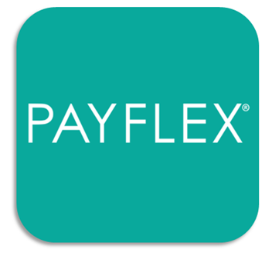Make payments
* View account alerts
* Check out the list of common eligible expense items
* And so much more!

## Download “PayFlex Mobile®” from your app store

PayFlex Mobile is available on most smartphones and tablets. Once you download the **PayFlex Mobile®** app, log in with the same username and password you use to access the PayFlex member website.   
Don’t have a username and password? No problem. Go to [**payflex.com**](http://www.payflex.com/) and click **SIGN IN**. Then, select **CREATE YOUR PROFILE**.

## Boost the security of your account with “Secure Access”

## When you log into the PayFlex app, you can set up “Secure Access”. It’s a more secure way to login. You’ll use your fingerprint or create a personal access code. This makes it more convenient for you and reduces the need for remembering a password!

## Questions?

Log in to **payflex.com** and select **Help & Support.**

Note: Standard text messaging and other rates from your wireless carrier still apply.

PayFlex Mobile**®** is a registered trademark of PayFlex Systems USA, Inc.

This material is for informational purposes only and is not an offer of coverage. It contains only a partial, general description of plan benefits or programs and does not constitute a contract. It does not contain legal or tax advice. You should contact your legal counsel if you have any questions or if you need additional information. In case of a conflict between your plan documents and the information in this material, the plan documents will govern. Eligible expenses may vary from employer to employer. Please refer to your employer’s Summary Plan Description (“SPD”) for more information about your covered benefits. Information is believed to be accurate as of the production date; however, it is subject to change. PayFlex cannot and shall not provide any payment or service in violation of any United States (US) economic or trade sanctions. For more information about PayFlex, go to **payflex.com.**

© 2018 PayFlex Systems USA, Inc.